

**MULTIMEDIA UNIVERSITY OF KENYA**

FACULTY OF COMPUTING & INFORMATION TECHNOLOGY

**Psychologist booking system**

BY

**NAME: BruceFelix Macharia Mwangi  
REG. No: CIT-223-015/2018**

**SUPERVISOR: James Omina**

**July 2022**

___________________________________________________________________________

Project Proposal submitted in partial fulfillment of the requirements of Bachelor of Science in Software Engineering/Computer Science

# **DECLARATION**

I hereby declare that this Project Proposal is my work and has, to the best of my knowledge, not been submitted to any other institution of higher learning.

**Student: BruceFelix Macharia Mwangi Registration Number: CIT-223-015/2018**

**Signature: ...................................... Date 22nd July 2022**

This Project Proposal has been submitted as partial fulfillment of requirements for the Bachelor of Science in Computer Science at the Multimedia University of Kenya with my approval as the University supervisor.

**Supervisor: James Omina**

**Signature: ..................................................... Date:**

**ACKNOWLEDGEMENT**

First and foremost, praise and thank God, the Almighty, for His showers of blessings throughout my work to complete the project successfully.

I would also to thank Ivy Murugi counseling and psychologist/ mental health advocate student from Nairobi University of Kenya for her guidance in understanding mental health.

I would like to express my deep and sincere gratitude to my project supervisor, Madam Yvette Otukana, for providing invaluable guidance throughout the project development process. Her dynamism, vision, sincerity, and motivation have deeply inspired me. She has taught me the methodology to carry out the research and to present the works as clearly as possible. It was a great privilege and honor to work and study under her guidance. I am extremely grateful for what she has offered me.

I am extremely grateful to my relatives for their love, prayers, care, and sacrifices in educating and preparing me for my future. I express my thanks to my sister. My Special thanks go to my friend and brother Paminus Murungi for the keen interest shown in completing this project successfully.

**Abstract**

Mental health includes our emotional, psychological, and social well-being. It affects how we think, feel, and act. It also helps determine how we handle stress, relate to others, and make choices. Mental health is important at every stage of life, from childhood and adolescence through adulthood.

It is estimated that 11.5 million, or one in every four Kenyans, have experienced mental illness. As of 2015, there were only around 12 neurologists and 100 psychiatrists in Kenya. Furthermore, mental health-related stigma decreases the accessibility of care since it can lead to discrimination. The country has limited resources for those struggling with mental health issues. The proposed system will bridge this gap by providing a platform where Kenyans can get access to psychologists at the touch of a button eliminating the need to go to a government facility. The main objective will be to bridge the gap between mental health experts and Kenyans in need of mental health care.

Agile methodologies take an iterative approach to software development. It consists of several smaller cycles called sprints. Each one of them is a project in miniature. Agile has a backlog and consists of design, implementation, testing, and deployment stages within the pre-defined scope of work. After each sprint, a potentially shippable product increment is delivered. This results in new features being validated early in the development.

**Table of Contents**

**Appendix 1: Cover page format** 1

**DECLARATION** 2

**List of Abbreviations.** 6

**List of Figures** 7

**List of Figures** 8

**Chapter 1 - Introduction** 9

1.1 Background of study 9

1.2 Problem statement 10

1.3 Aim of study 10

1.3.1 Research objectives 10

1.4 Justification of study 11

1.5 Scope 11

1.6 Assumptions 11

1.7 Limitations 12

**2.1 CHAPTER 2 Literature Review** 13

2.2 Introduction 13

2.2 Related systems. 13

2.2.1 GoodTherapy 13

2.2.2 CBTKenya 13

2.3 Limitations of these systems 14

2.3.1 GoodTherapy 14

2.3.2 CBTKenya 14

2.4 Proposed solution 15

**Chapter 3 - Methodology** 16

3.2 Introduction 16

3.2 Agile Methodology 16

3.2 Data collection methods and tools 18

3.4 Project Resources 19

3.5 Project Budget 20

3.6 Project Schedule 20

**References** 21

**Appendix** 22

# **List of Abbreviations.**

* **CBT –** Cognitive Behavioral Therapy.
* **WHO –** World Health Organization.
* **FAQs -** Frequently Asked Questions.
* **ITP –** Individualized Treatment Plan
* **XP –** Extreme programming.

# **List of Figures**

Figure 1Kanban agile methodology 18

# **List of Figures**

Table 1Project Budget 19

Table 2Project Schedule 19

# **Chapter 1 - Introduction**

# 1.1 Background of the study

Mental health includes our emotional, psychological, and social well-being. It affects how we think, feel, and act. It also helps determine how we handle stress, relate to others, and make choices. Mental health is important at every stage of life, from childhood and adolescence through adulthood.

According to the World Health Organization, mental health is "a condition of well-being in which the individual recognizes his or her strengths, can cope with the usual stresses of life, can work successfully and fruitfully, and can contribute to his or her community" (WHO).  Subjective well-being, perceived self-efficacy, autonomy, competence, intergenerational dependency, and self-actualization of one's intellectual and emotional potential are all examples of mental health.

The WHO stresses that mental health is “more than just the absence of mental disorders or disabilities.” Peak mental health is about not only avoiding active conditions but also looking after ongoing wellness and happiness. They also emphasize that preserving and restoring mental health is crucial on an individual basis, as well as throughout different communities and societies the world over.

The journey toward transforming mental health care systems in Kenya has gathered momentum following the launch of the Kenya Mental Health Action plan (2021-2025). Dr. Mercy Mwangangi points out that mental health remains an integral pillar in the country’s health system and social-economic development. She called for concerted efforts to boost mental health care systems through investment, dedication, and planning for resources, coordination, oversight, awareness creation, and advocacy.

The Kenya Mental Health Policy 2015-2030 provides a framework for interventions for securing mental health systems reforms in Kenya. This is in line with the Constitution of Kenya 2010, Vision 2030, the Kenya Health Policy (2014- 2030), and the global commitments. The Constitution of Kenya 2010, in article 43. (1)(a) Provides that “every person has the right to the highest attainable standard of health, which includes the right to healthcare services” 1.

# 1.2 Problem statement

It is estimated that 11.5 million, or one in every four Kenyans, have experienced mental illness. As of 2015, there were only around 12 neurologists and 100 psychiatrists in Kenya. Furthermore, mental health-related stigma decreases the accessibility of care since it can lead to discrimination. The country has limited resources for those struggling with mental health issues.

Kenya is among countries facing funding constraints for mental health services as demand rises sharply due to the Covid-19 pandemic. A survey by the World Health Organization shows that critical funding gaps are halting and disrupting crucial mental health services in Africa. In Kenya, WHO data estimates that 1,408 people commit suicide yearly, or simply put, four deaths daily. Kenya was ranked at position four in Africa with 1.9 million people who were suffering from depression.

The Kenyan government budget allocation fund for mental health stands at 0.1% annually. Given the scarce resources, there are few government employees mental health professionals available to cater to the entire population of Kenya. A gap thus needs to be filled to provide Kenyans with mental health care. To sum it up, millions of Kenyans are suffering in silence, unable to get the help they need, while the country has few specialists to handle mental problems.

The proposed system will bridge this gap by providing a platform where Kenyans can get access to psychologists at the touch of a button eliminating the need to go to a government facility.

# 1.3 Aim of the study

This study aims to build a system or platform to provide mental health services to Kenyans. By enabling Psychologists to provide mental health care to Kenya anywhere and anytime.

# 1.3.1 Research objectives

Regarding mental health status in Kenya, the following are the objectives of this project.

* Build a psychologist booking system
* Incorporate a Chabot in the system to provide a virtual entity one can talk to before seeing a psychologist.

# 1.4 Justification of the study

The main objective will be to bridge the gap between mental health experts and Kenyans in need of mental health care. This will be achieved by building a system that Kenyans can use to search for and book appointments either physical sessions or online sessions. This system will be tailored in a way that it can be easy to use and find its way around the proposed system. A page will also be available to educate users on the issue of mental health and how to go about it.

Other significances of this study:

* It will enable people to be more open to seeking therapy than in fear of being stigmatized.
* It will also open up another avenue for mental health professionals to make money and help other people aside from their day-to-day jobs.

# 1.5 Scope

The system will be web-based that will entail the following:

* A login/sign up page
* FAQs page
* A Chabot to engage the user and try and pacify the problem they are dealing with before recommending away in therapy.
* A landing page
* A psychologist booking page
* An admin panel.

# 1.6 Assumptions

For this system to be a success and meet the desired objectives some factors and considerations have to be met.

1.       The Psychologist must be a registered specialist with credible papers.

2.       The users using the system to seek help must disclose their information honestly without withholding anything.

# 1.7 Limitations

Internet connection will be a must to access the system. In addition to that, there are very few trained psychologists in Kenya. There are people in Kenya who attribute mental health to curses and other cultural myths and this poses a challenge to try and educate and help people in need of mental health. Furthermore, the cost of hiring a psychologist is not cheap. Kids or underage people might face the problem of not being able to access the services offered by the psychologist booking system since they will need guardian guidance.

# **2.1 CHAPTER 2 Literature Review**

# 2.2 Introduction

This chapter presents a review of literature pertinent to the study objectives based on the problem of lack of access to mental health facilities and help from professionals. The purpose of this chapter is to review relevant literature information that is related and consistent with the objectives of the study. The literature review sought to bring out the existing body of knowledge relevant to mental health care, criticize the work and identify the gaps. It covers a few of the existing systems and platforms that are both local in Kenya and International. It will breakdown how this systems works and their weaknesses

# 2.2 Related systems.

# 2.2.1 GoodTherapy

GoodTherapy is a web platform built-in in 2007 by Noah Rubinstein, a licensed marriage and family therapist based in Olympia, Washington. It was formed to form a network of mental health professionals committed to ethical, collaborative, and non-pathologizing practices that put people in therapy first. GoodTherapy.org’s membership has grown to more than 25 countries, all with one goal in mind: to empower people to live healthier, happier lives. From the beginning, it has been educating the public about the benefits of psychotherapy.

GoodTherapy.org maintains the highest membership requirements, verifying that each applicant meets strict educational, licensure, and philosophical guideline. It aims to fight stigma, increase access to mental health services, and promote positive change on both a personal and cultural scale. The primary modes of therapy offered typically include individual, couples, family, and group therapy, and different circumstances may call for different modes.

# 2.2.2 CBTKenya

CBT-Kenya (Cognitive Behavioral Therapy-Kenya) is a psychotherapy platform that offers counseling and therapy sessions for persons from all walks of life. They work alongside other professional psychologists in East Africa who are dedicated to helping clients gain insight into themselves by going through a healing process. They achieve these through the client and therapist exploring past and present issues.

They shun the assumption that one size fits all. They administer a comprehensive screening and assessment process that helps them to understand the nature and causes of the presenting problems. Subsequently, an individualized treatment plan (I.T.P) is prepared for their clients.

Since their treatment is founded on the biopsychosocial treatment model, the individual is assessed and treated holistically. In some cases, the psychotherapist makes referrals to a psychiatrist, physician, or other mental health experts.

Their approach is based on three steps: Screen, Assessment and final step is treatment planning.

# 2.3 Limitations of these systems

# 2.3.1 GoodTherapy

One of the main disadvantages of good therapy is that they only have one Kenyan therapist that is based here locally in Nairobi only – Anne Njoki who is located in Westlands. This poses a challenge as one psychologist cannot meet the entire population demand of Kenya.

This also poses a challenge as this psychologist cannot offer all manner of therapies and thus is limited to a few options.

Another challenge is that it only offers a face-to-face session which is not convenient for clients who would like an online session where COVID19 brought about online meetings to limit human interactions to curb the spread of the virus.

Furthermore, GoodTherapy doesn’t offer a rating system thus clients won’t be able to tell if they are a credible therapist from the onset of looking for help.

# 2.3.2 CBTKenya

CBTKenya has several limitations that inhibit it from delivering its services to many Kenyans in need of therapy. One of them is that it is limited to three psychologists available only. The three of them are not enough to meet the shortage of psychologists in Kenya.

The other limitation is that it is located in Nairobi only. This means they only serve Nairobi and its environs leaving the marginalized areas with no one to tend to them.

The other major limitation is that they mainly work with clients with Bio-psychosocial and spiritual issues that present as anxiety, depression, alcohol and substance use insomnia, and anger.

Lastly, CBTKenya has fixed timelines that offer face-to-face therapy sessions. They open during the week from 8:00 am to 5:00 pm, Saturday 8:00 am to 1:00 pm and they do not offer Sunday services. These timelines are quite rigid and some clients might need immediate assistance.

# 2.4 Proposed solution

The above systems aim at providing mental health services but they have some limitations that pose a challenge to solving the problem at hand. The proposed solution aims at solving these problems in the following ways.

It will provide a platform where all psychologists based in Kenya can register and offer their services across the country based on their locations. In addition to that, they will be able to offer both physical and online services.

A pool of psychologists will also be available to clients in need rather than the few numbers provided by the mentioned systems. It will also include a rating system feature to enable users to decide on which therapist they should choose.

The system will also offer all forms of therapy with their respective professionals from Accelerated Experiential Dynamic Psychotherapy, counseling (Trauma), psychotherapy, and many more. Lastly, a chatbot will be incorporated into the web platform to assist the user before finding an appropriate psychologist that matches their needs.

# **Chapter 3 - Methodology**

# 3.2 Introduction

A system development methodology refers to the framework that is used to structure, plan, and control the process of developing an information system. When it comes to software development SDLC is the process that takes place. It consists of a phase that system developers follow during the process of system development. There are different methods of system development life cycle and for this project, I will use the agile methodology.

This chapter describes the methodology that will be used in developing the Psychologist’s booking system. It will describe the methodology itself, and the justification for using the methodology. In addition to the methodology, it will also describe the methods of data collection.

# 3.2 Agile Methodology

Agile is an iterative approach to project management and software development that enables teams to deliver value to clients more quickly and with fewer headaches. An agile team delivers work in modest, yet consumable, increments rather than putting all on a "big bang" launch. Continuous evaluation of requirements, plans, and results provides teams with a natural mechanism for adjusting rapidly to change.

Agile methodologies take an iterative approach to software development. It consists of several smaller cycles called sprints. Each one of them is a project in miniature. Agile has a backlog and consists of design, implementation, testing, and deployment stages within the pre-defined scope of work. After each sprint, a potentially shippable product increment is delivered. This results in new features being validated early in the development.

**Main Aspects of Agile**

* **Flexibility –** the scope of the project may change according to new requirements.
* **Work breakdown –** the project consists of small cycles (known as Sprints in scrum).
* **Value of teamwork –** Team members work closely together and have a clear vision of their responsibilities.
* **Cooperation with the client –** A customer is closely engaged and can change the requirements or accept the team’s suggestions.

**Benefits**

* Ability to manage the changing priorities.
* Increased productivity through daily small tasks allocated to each member.
* Better project visibility due to the simple planning system.

**Agile Frameworks, Practices, and Methodologies**

Agile is an umbrella phrase for a wide range of processes and techniques that share the above-mentioned concepts and ideals. Each one has its own set of applications and distinguishing characteristics. Scrum, Kanban, Hybrid, Lean, Bimodal, XP, and crystals are the most prominent frameworks and methods.

In this methodology, I choose to work with Kanban. It is another common framework used to implement agile project management. It is a simple, yet powerful approach to developing software products. Its wriggles go down to a visual system of cards used in Toyota manufacturing as a production control method.

**Kanban Working Principles**

Kanban means “Visual signal” in Japanese. It focuses on the visualization of the workflow and priorities the work in progress, limiting its scope to match it effectively to a team’s or person’s capacity.

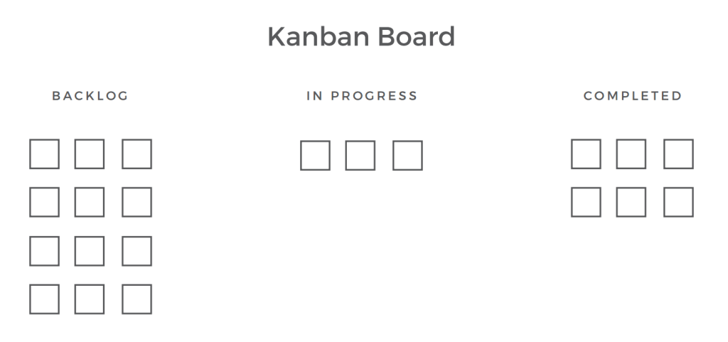

Figure 1Kanban agile methodology

As soon as a task is complete, the next item from the pipeline can be worked on. It thus offers more flexibility in planning, faster turnaround, clear objectives, and transparency. The project development is based on the workflow visualization through a Kanban board, usually represented by sticky notes and whiteboards or online tools like Trello. Trello automates and digitalizes Kanban.

The ability to track progress helps the developer understand everyone’s input in achieving the common goal, resulting in a focus on completing the task well and on time.

**Kanban as methodology Justification**

Kanban results in small releases and adapts to changing priorities. Kanban is focused on doing small pieces of work as they come up. It also improves productivity and efficiency. It also increases the visibility of flow and delivery speed/ throughput.

# 3.2 Data collection methods and tools

Data collection methods can be broken down into two methods.

1.      Primary – This is original, first-hand data collected by the data researchers.

2.      Secondary data is second-hand data collected by other parties and already having undergone statistical analysis. This data is either information that the researcher has tasked other people to collect or information the researcher has looked up.

The main primary data collection methods in this project entailed:

* Interviews – I asked questions from a large sample of perusing direct interviews.
* Focus groups – It involves anywhere from a half-dozen people, led by a moderator, brought together to discuss the issue.
* Questionnaires – respondents got a series of questions, either open or close-ended, related to the matter at hand.

The main secondary Data collection methods in this project will entail: The internet and the Kenya Mental Health Action plan 2021-2025 from the ministry of Health

**3.3.2 Data collection tools**

Data collection tools refer to the devices/instruments used to collect data, such as paper questionnaires or computer-assisted interviewing systems. Tools involved in this project were:

* Word Association - Respondents will receive
* A set of words and asked what comes to mind when they heard each word?
* In-Person Surveys – I will ask questions in person.
* Observation – It was effective in small-scale situations

**3.3.3 Data sets**

A data set is a collection of data. The main sources of data sets will be from the internet which will include blogs and journals.

# 3.4 Project Resources

Project resources are essentially the resources required for the successful development and completion of a project. These resources can include capital, people, materials, tools, or supplies that are required to complete specific tasks in a project. The project requirement resources in this project will be:

* Human Resource – The developer – me and the Project supervisor.
* Hardware and Software tools – My laptop, VScode, a web browser.

# 3.5 Project Budget

The total expected project budget is as follows:

Table 1Project Budget

|  |  |
| --- | --- |
| **ITEM** | **COST** |
| Internet services for research | 2000/= |
| Laptop for the development purpose | 35000/= |
|  |  |

# 3.6 Project Schedule

Table 2Project Schedule

|  |  |  |  |  |  |  |  |  |  |  |  |  |  |  |  |
| --- | --- | --- | --- | --- | --- | --- | --- | --- | --- | --- | --- | --- | --- | --- | --- |
|  | Week | | | Weeks | | | | | | | | | | | |
| Task | Start | End | Duration | 1 | 2 | 3 | 4 | 5 | 6 | 7 | 8 | 9 | 10 | 11 | 12 |
| UI Design | 1 | 2 | 1 |  |  |  |  |  |  |  |  |  |  |  |  |
| Front-end code | 2 | 4 | 2 |  |  |  |  |  |  |  |  |  |  |  |  |
| Backend Code | 4 | 7 | 3 |  |  |  |  |  |  |  |  |  |  |  |  |
| Initial Test | 7 | 8 | 1 |  |  |  |  |  |  |  |  |  |  |  |  |
| Chatbot | 8 | 10 | 2 |  |  |  |  |  |  |  |  |  |  |  |  |
| Integration of Chatbot and Web | 10 | 11 | 1 |  |  |  |  |  |  |  |  |  |  |  |  |
| Beta Release | 11 | 12 | 1 |  |  |  |  |  |  |  |  |  |  |  |  |
| Final Release |  |  |  |  |  |  |  |  |  |  |  |  |  |  |  |

# 

# **Chapter 4 System Analysis**

# 4.1 Detailed analysis of current system.

The essential components of an Information System, how data moves within the system, user-interaction points, and the Authorization Boundary are all captured in the Information System/Data Flow Diagram.

**4.1.1 Flowchart**

Registration flowchart

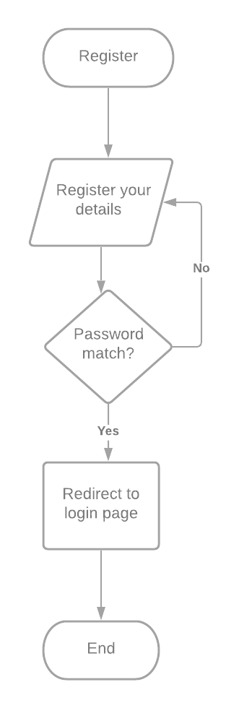

Figure 2: Registration Flowchart for the current system

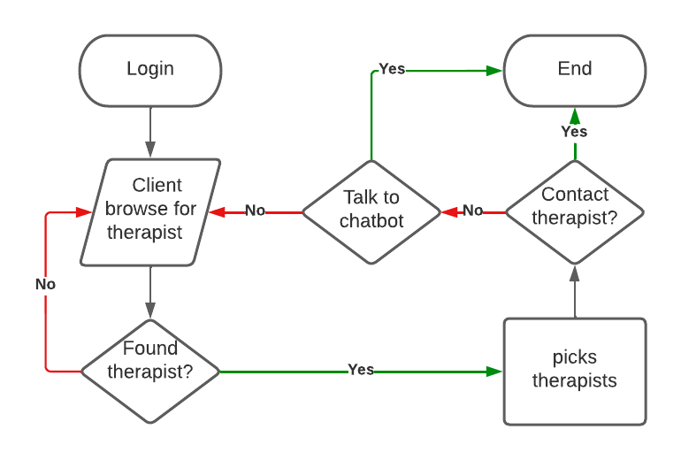

Figure 3 Client looking for therapist procedure.

**4.1.2 Use case Diagram**

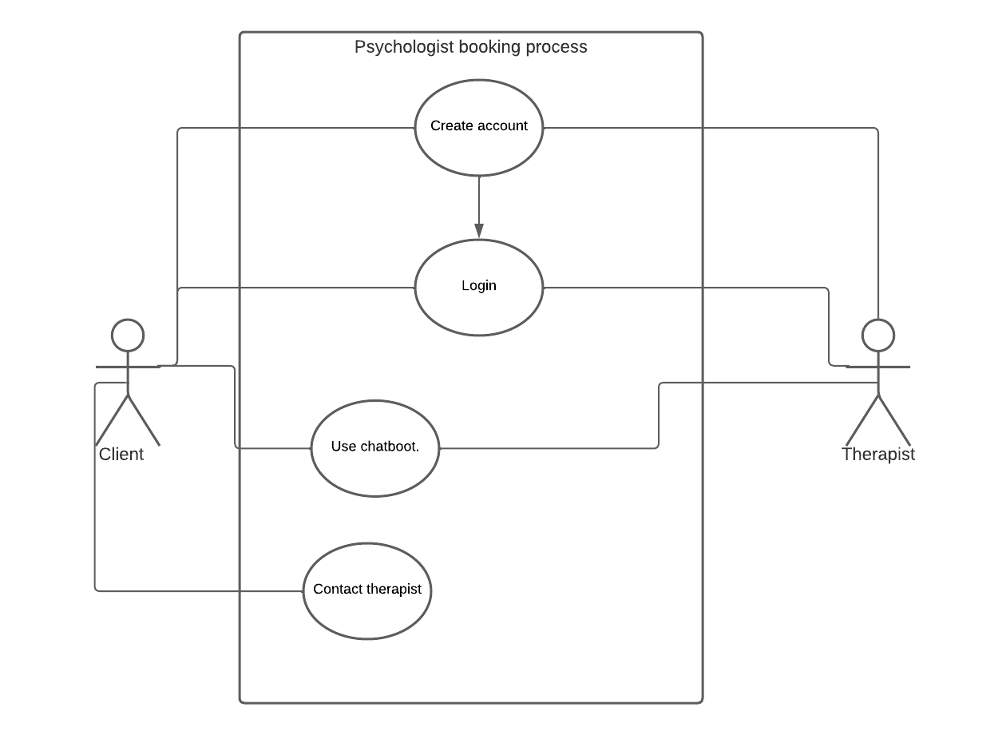

**4.2 System requirements**

The features and behavior of a system or software application are described in system requirements. It consists of a number of parts that seek to define the customer's intended functionality in order to please their various consumers. In addition to stating how the system should act, the specification also describes at a high-level the core business processes that will be supported, what simplifying assumptions have been made and what critical performance parameters will need to be met by the system.

**4.2.1 Functional requirements**

A Functional Requirement is a statement that describes the service that the software must provide. It refers to a software system or a component of one. A function is nothing more than the inputs, behavior, and outputs of a software system. A calculation, data manipulation, business procedure, user interaction, or any other unique functionality that defines what function a system is likely to execute can all be considered. Functional Requirements are also known as Functional Specification in Software Engineering. A Functional Requirement can range from a high-level abstract explanation of the sender's need to detailed mathematical functional requirement specifications in software engineering and systems engineering. Functional software requirements assist you in capturing the system's intended behavior.

The client should be able to:

1. Register his/her credentials in the system.
2. Log in to the system.
3. Contact the therapist directly.
4. Interact with the chatbot.

The therapist should be able to:

1. Register his/her credentials in the system.
2. Interact with the client.
3. Call the client.
4. Use the chatbot.

**4.2.2 Non-Functional requirements**

The limits or requirements imposed on the system are known as non-functional requirements. They define the software's quality attribute. Scalability, maintainability, performance, portability, security, and dependability are all examples of non-functional requirements. Non-Functional Requirements address critical software quality issues.

The system needs:

* A browser
* A computer with preferable with over 2Gigabytes of RAM
* A database host
* Access to internet
* Database security
* Working internet connection or locally hosted server XAMMP server.

# **Chapter 5 System Design**

# 5.1 Architectural Design

**5.1.1 Flowchart**

Flowchart is a diagrammatic representation of sequence of logical steps of a program. Flowcharts use simple geometric shapes to depict processes and arrows to show relationships and process/data flow.

# **References**

1. Felman, A. (2020, April 13). *Mental health: Definition, common disorders, and early signs*. [Www.medicalnewstoday.com](http://Www.medicalnewstoday.com). <https://www.medicalnewstoday.com/articles/154543#definition>

2. Wikipedia Contributors. (2019, January 9). *Mental health*. Wikipedia; Wikimedia Foundation. <https://en.wikipedia.org/wiki/Mental_health>

3. *The Taskforce on Mental Health - Ministry of Health*. (n.d.). The Taskforce on Mental Health. Retrieved February 28, 2022, from <https://mental.health.go.ke/>

4. *Mental Health Issues In Kenya - 1226 Words | Internet Public Library*. (n.d.). [Www.ipl.org](http://Www.ipl.org). Retrieved February 28, 2022, from <https://www.ipl.org/essay/Examples-Of-Mental-Health-Stigma-In-Kenya-FJQSJ3NPU>

5. <https://www.the-star.co.ke/authors/johnmuchangi>. (n.d.). *Mental health problems rise in Kenya during a pandemic*. The Star. <https://www.the-star.co.ke/news/2020-10-09-mental-health-problems-rise-in-kenya-during-pandemic/>

6. *Mental Health Issues In Kenya - 1226 Words | Internet Public Library*. (n.d.). [Www.ipl.org](http://Www.ipl.org). Retrieved February 28, 2022, from <https://www.ipl.org/essay/Examples-Of-Mental-Health-Stigma-In-Kenya-FJQSJ3NPU>

7. *Counselling and Psychotherapy Services- Nairobi-CBT-Kenya*. (n.d.). CBT Kenya. Retrieved March 16, 2022, from https://www.cbtkenya.org/counselling-and-psychotherapy-services-nairobi-cbt-kenya/

8. *GoodTherapy - Find the Right Therapist*. (2019). Goodtherapy.org. https://www.goodtherapy.org/

9. *Anne Njoki Msc.Clinical Psychology, UoN (Relationships & Mental health specialist) and Mediation, SoM- U.K (Family & Commercial)*. (n.d.). Www.goodtherapy.org. Retrieved March 16, 2022, from https://www.goodtherapy.org/therapists/profile/anne-njoki-20200514

# **Appendix**

**Questionnaire**

1. How old are you?
2. What is your gender?
3. Overall how would you rate your physical health?
4. Are you going through an emotional situation?
5. Do you use any drugs?
6. What is your relationship status?
7. How is your quality of sleep?
8. How often do you feel positive about your life?
9. When was the last time you had a positive outlook on life?
10. Have you ever been diagnosed with a mental disorder before?
11. When did you last get your mental health examination done?
12. Do you feel content with your relationships and family?
13. Is there a history of mental disorders in your family?
14. If “Yes”, please select which of the family member(s) had a history of mental illness?
15. Have you seen a therapist in the recent past?
16. How easy is it for you to access mental health care?